Dashboard
Title: product placement dashboard
Description:
The dashboard provides an interactive overview of the Strategic Product Placement Analysis project. It combines product category, sales volume, product position, seasonal impact, competitor pricing, consumer demographics, foot traffic, pricing, and promotional analysis into a single view. This dashboard helps businesses identify the most effective product placement strategies and supports data-driven decision-making.
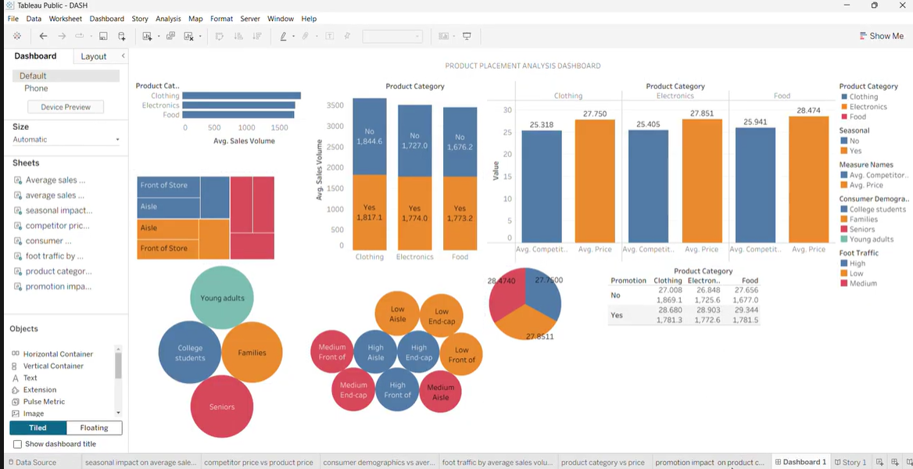

Story
Description:
The story presents the complete analysis of the Strategic Product Placement Analysis project in a step-by-step manner. It guides users through key visualizations, including average sales volume by product category, product position, seasonal impact, competitor pricing, consumer demographics, foot traffic, product pricing, and promotion impact. The story enables users to understand insights sequentially and make informed business decisions based on the analysis.
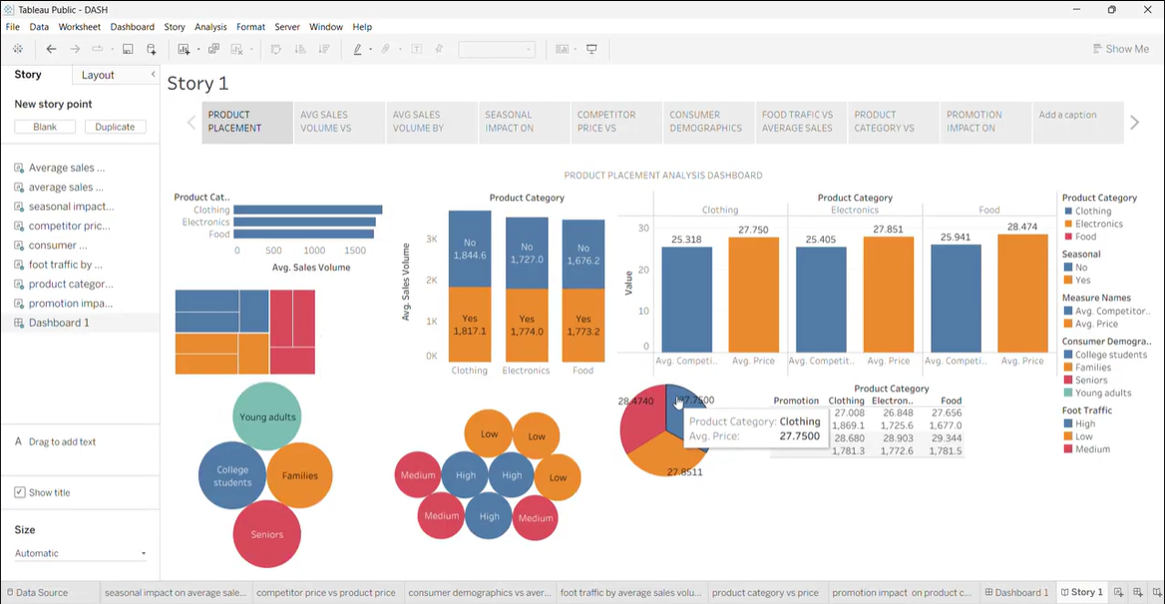
Publish link : https://public.tableau.com/app/profile/syamasreeja.madhavarapu/viz/DASH_17835339959140/Story1

